- Introduction
In the fast-paced world, processing a large amount of raw data is an essential skill and helpful in creating an accurate and reliable model. This report aims to explore the real-world dataset by using Python and Pandas, in order to load and analyse the dataset, summarise the characteristics, and check the quality issues, like missing values. From finding the real-world data to import to Jupyter, then printing out all the information in the dataset to better understand the content, and saving more time to analyse the important information. By showing the detailed analysis and correlation exploration, this assignment helps to build a strong foundation for future data and modelling tasks.

- Dataset Description
The dataset “Rich_Global_Condom_Usage_Dataset” is collected from (Kaggle), with 550 rows and 15 columns. The reason that I chose this dataset was that, as a MAN, I am really curious about condom use around the world and how different it is between countries, and I was surprised when I saw some data information.
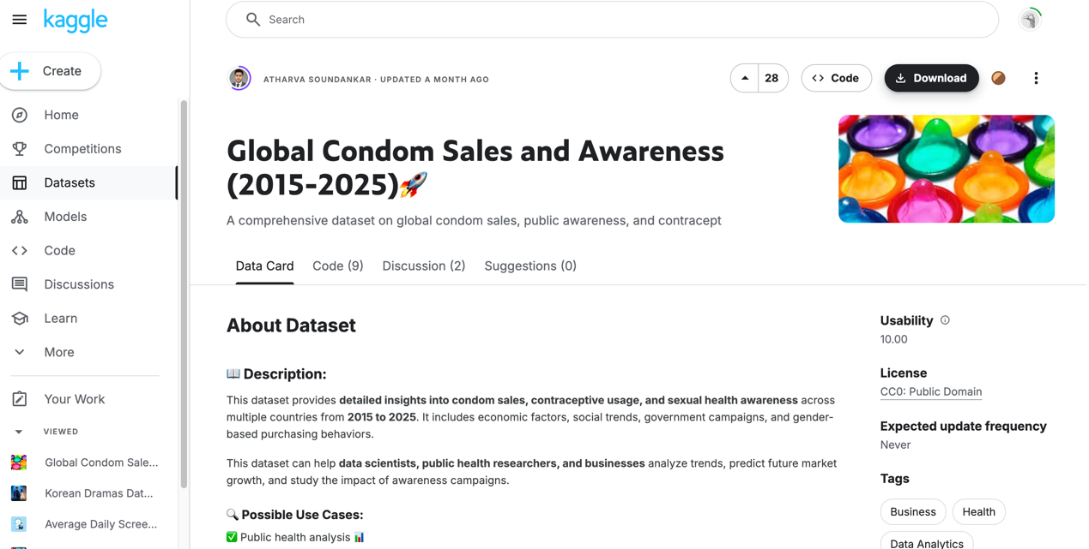Reference:
Atharva Soundankar. (2015). Global Condom Sales and Awareness (2015-2025)🚀. Kaggle.com. https://www.kaggle.com/datasets/atharvasoundankar/global-condom-sales-and-awareness-2015-2025

It seems to illustrate condom use rates by country and income group other socioeconomic indicators together with the intricate details of condom sales and sexuality, sexual health awareness, and sexual health utilization between 2015 to 2025. It includes such variables as country, region, income group, rates of usage, as well as some other pertinent health indicators. The dataset came from an open-access repository and contains some information gaps that need addressing.
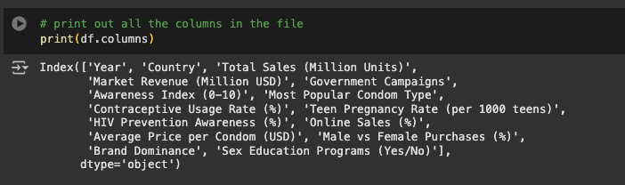
Column data types:
Year int64
Country object
Total Sales (Million Units) int64
Market Revenue (Million USD) float64
Government Campaigns object
Awareness Index (0-10) float64
Most Popular Condom Type object
Contraceptive Usage Rate (%) float64
Teen Pregnancy Rate (per 1000 teens) float64
HIV Prevention Awareness (%) float64
Online Sales (%) float64
Average Price per Condom (USD) float64
Male vs Female Purchases (%) object
Brand Dominance object
Sex Education Programs(Yes/No)

The missing value is not in this dataset, so I will manually make the missing value in the later part.

- Data Processing Outcomes
This dataset covers the global condom usage trends across several countries from 2015-2025, including 550 rows and 15 columns.
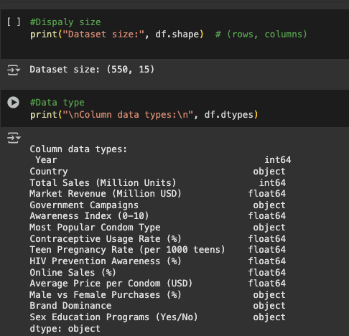
df.head () screenshot report:
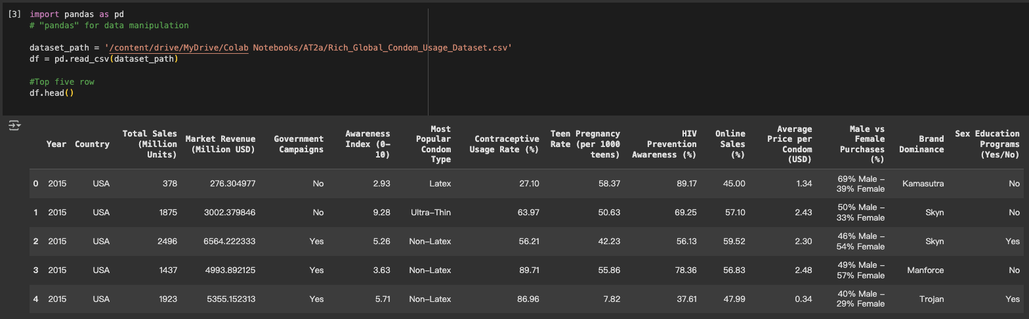

The first few rows (df.head()) show data from the USA between 2015 and 2019. This tells us that the dataset is organized chronologically, and countries may have multiple records across different years.

df.tail () screenshot report:
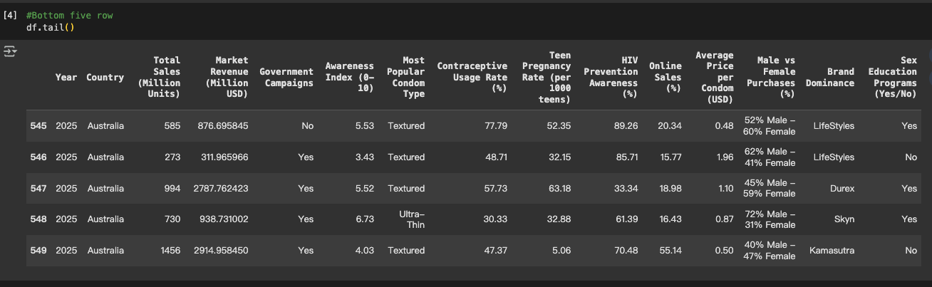 The last few rows ( df.tail() ) focus on Australia from 2021 to 2025. This confirms that the dataset continues through to more recent years and includes detailed breakdowns by country and year.
Dataset Structure & First Impressions
There’s a good mix of numerical and categorical columns here — for example:
- Numerical: Total condom sales, revenue, awareness index, teen pregnancy rates, etc.
- Categorical: Country, top condom brands, distribution channels, presence of sex education programs.
The dataset appears well-organized; importantly, there are no missing values, making it easier to work with. Every row represents a country-year pair, giving us a snapshot of how things evolve.
Descriptive Stats – What the Numbers Tell Us
df.describe () #Explore the summary statistics
#standard deviation, minimum, maximum, and quartiles
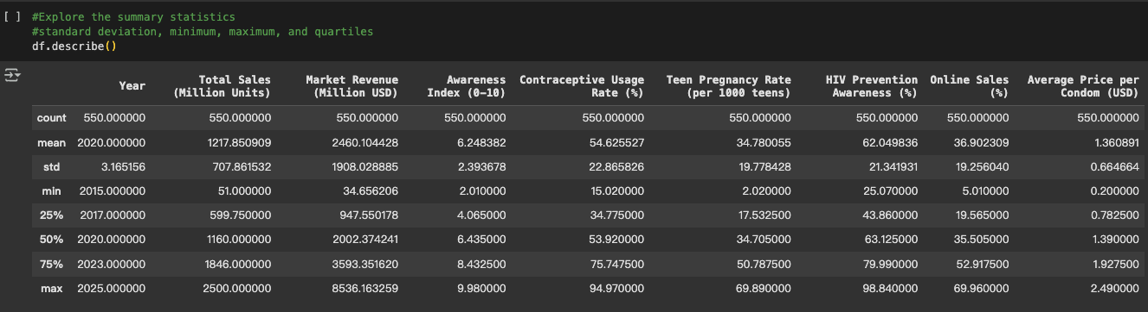

Total Sales (Million Units)
- Mean: ~1,218 million units
- Min–Max: from 51 million to 2,500 million
- There’s a huge change in sales, which suggests some countries are very high and demand and others are still developing markets.
- 25th percentile is ~600 million, and 75th percentile is ~1.85 billion, this spread shows a lot of inequality in distribution.
Market Revenue (Million USD)
- Mean: ~$2.46 billion
- Standard Deviation: ~$1.9 billion
- These value numbers show plenty of dispersion owing to pricing segmentation, scale of markets, and even the consideration of powerhouses dominating countries.
Awareness Index (0–10)
- Mean: 6.24
- Min–Max: 2.01 to 9.98
- This index shows an okay average score, but some countries are scoring really low.
- The level of awareness focused on education-backed campaigns is significantly lacking in most countries, with below 9.9% and 4.07% falling into 25%
Contraceptive Usage Rate (%)
- Mean: 54.63%
- Spread: 15% to 94.97%
- While some cut essential aid for others, the lag among perceived developed an aid surge, resulting in significantly more aid available.
- Closer median and mean of 53.92% indicate reasonably proportional distribution relatively small span between the maximum and minimum range.
Teen Pregnancy Rate (per 1000 teens)
- Mean: ~34.78
- Ranges from 2 to almost 70 pregnancies per 1000 teens.
- A lower number is better, and this spread may reflect differences in education, access to contraceptives, and cultural attitudes.
- Interestingly, 75% of countries are below 51 pregnancies per 1000 teens.
HIV Prevention Awareness (%)
- Mean: 62.05%
- Min–Max: 25% to almost 99%
- Online Sales (%) Mean is recorded at 36.9 with a minimum of 5% and a maximum of almost 70%. It is a positive indicator that there is rampant online sales but there seems to be little variation across regions which leads to suggest countries still relying heavily on pharmacies and in-person channels.

Online Sales (%)
- Mean: ~36.9%
- Lowest recorded: 5%, highest: almost 70%
- It is a positive indicator there is rampant online sales but there seems little variation across region which leads to suggest countries still relying heavily on pharmacies and in person channels.

Average Price per Condom (USD)
- Mean: $1.36
- Min–Max: $0.20 to $2.49
- There’s more than a 10x difference in pricing, possibly reflecting regional economies, taxes, or brand premiums.
- The median price is $1.39, suggesting most countries hover around that range.
Categorical Frequency Tables
I chose the Most Popular Condom Types because I was curious about the result:
Most common: Textured
Less frequent, possibly trend-based preferences: Flavored, Ultra-thin, Glow-in-the-dark
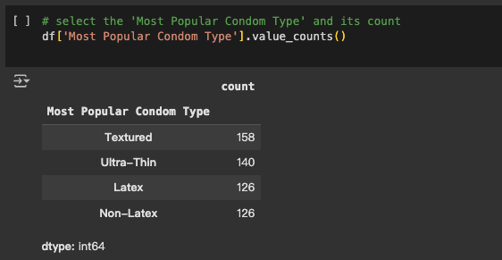
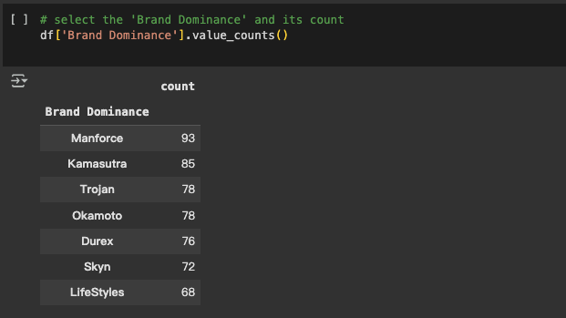
The most dominant condom brands: Manforce, Kamasutra, Trojan.
I was surprised by the result that the most popular brand is Durex, but it is not the first of the ranks.

Selected Columns and Filtering
To filter the dataset,I applied filtered to clean up the dataset, excluded any records where total sales were zero or negative, as such values are either invalid or unhelpful for analysis.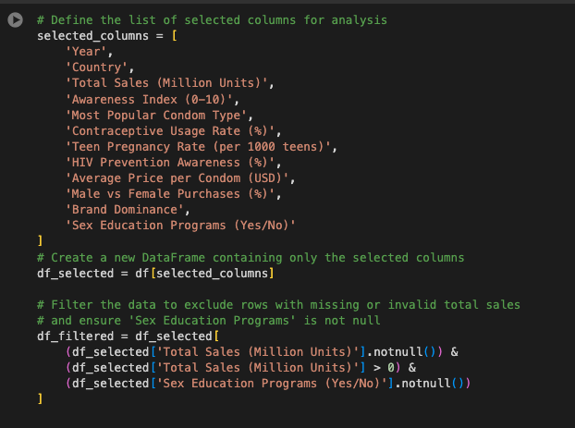
I explored the "Male vs Female Purchases (%)" column to see how condom purchase patterns differed by gender. The frequency distribution below shows that the majority of gender breakdowns are quite unique, with only a few repeated values across the dataset.
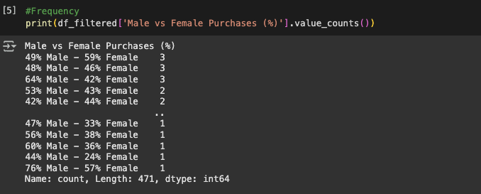

Correlation Insights – What’s Connected?

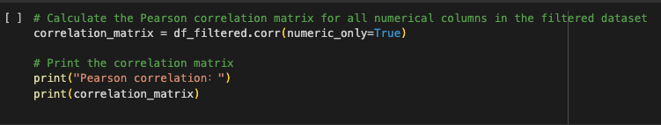

I ran a correlation matrix to see how different numerical columns relate to each other. A few things stood out:
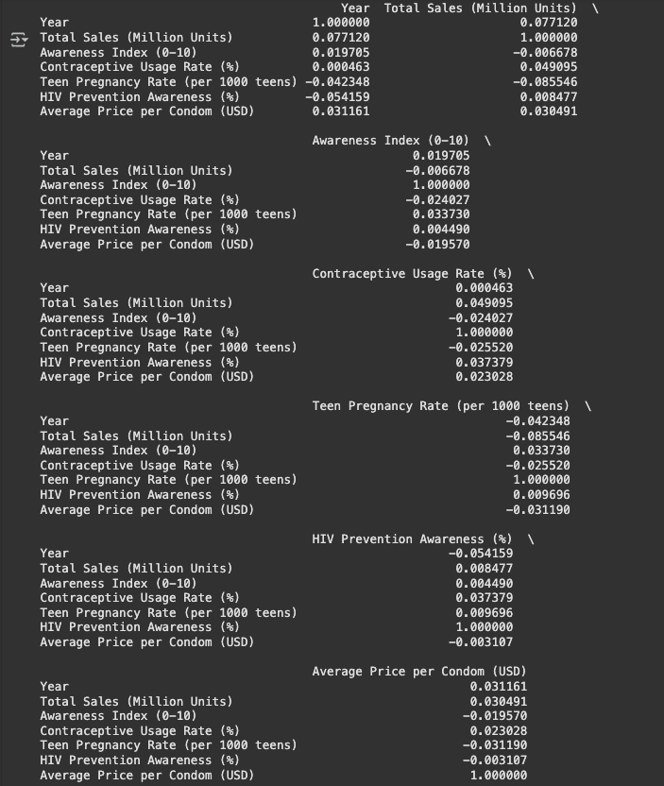
• There appears to be a strong correlation with Total Sales and Market Revenue (~0.75), which is logical - selling more units results in more revenue.
• It is interesting that the Awareness Index does not have a strong correlation with Contraceptive Use or Teen Pregnancy Rates. This means that just knowing about condoms doesn't automatically guarantee their usage — access, stigma, or education could also be factors.
• Online Sales appear to have an upward trend over time, even if it is slight.
As a whole, the strongest relationship was between Sales and Revenue, while most health-related factors showed weaker correlations, suggesting that more complex social dynamics is affecting those other factors.
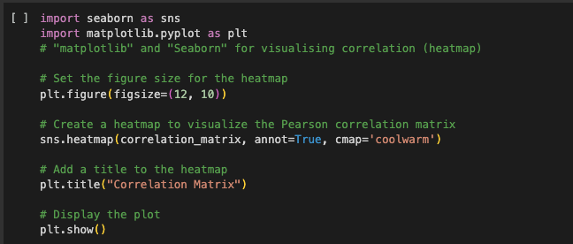
This code creates a correlation matrix heatmap using Seaborn and matplotlib libraries.

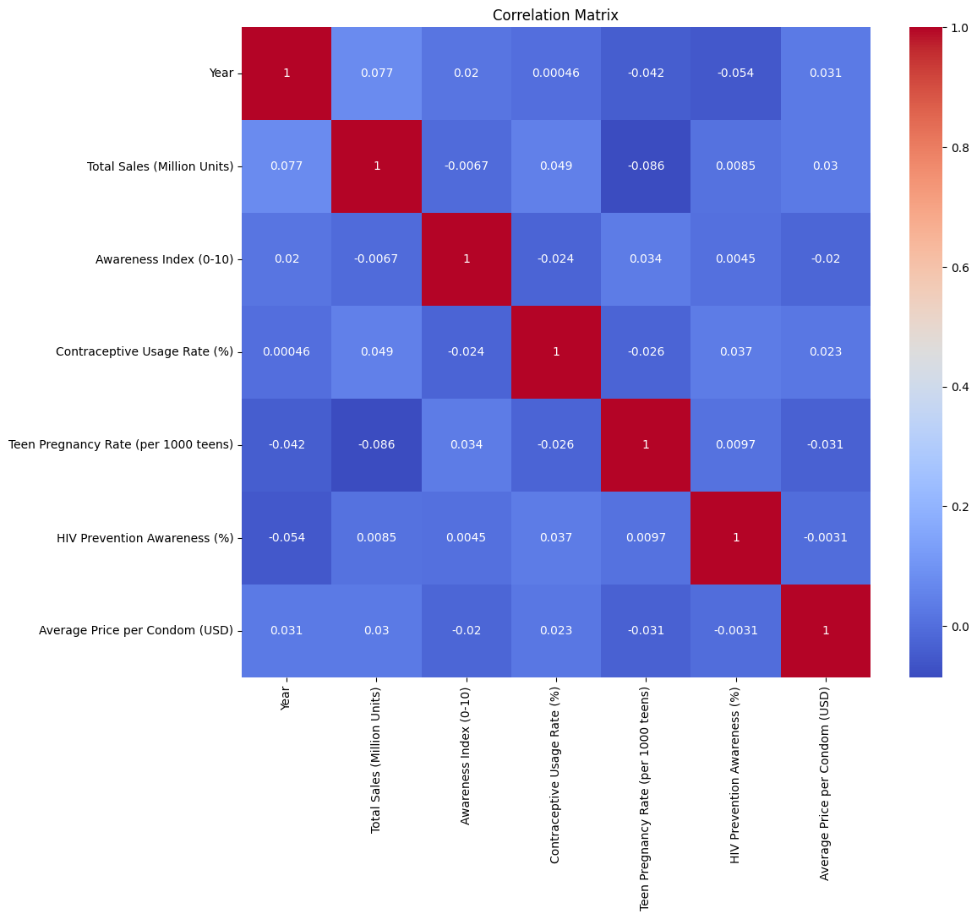
- Data Quality
To make sure the dataset does not contain any redundant numbers, I filter the duplicated rows.
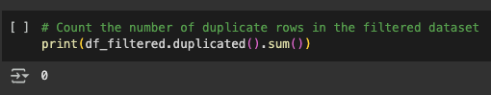
Result is 0, means that no duplicate records were found in the filtered dataset.

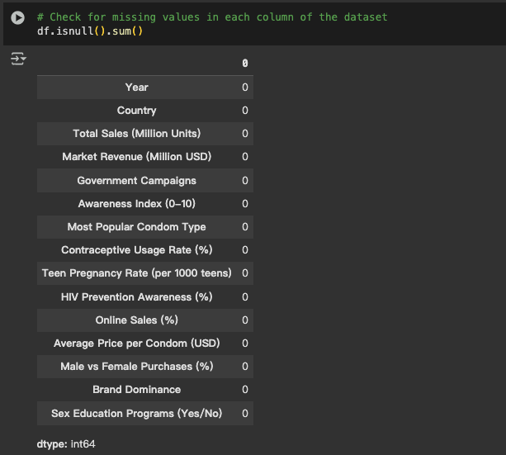
I used the df.isnull().sim() to check for any missing value in the dataset, as we can see there is no missing value across any of the columns. To meet the assignment requires, I will manually introducing missing values by using numpy.
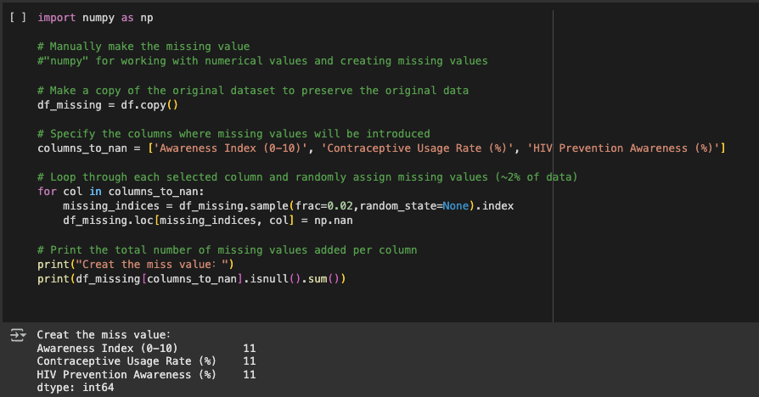
To manually create the missing value in the dataset by using the np.nan function to assign missing values in the dataset. Then three columns and randomly assigned missing values to approximately 2% of the data using sample(frac=0.02). As a result, each of the columns had 11 missing values.
One of the challenges I met was to create missing values, so I changed some numbers to “miss”, which is not the real “NaN” it is just a string. In that case, the isnull() will not detect it.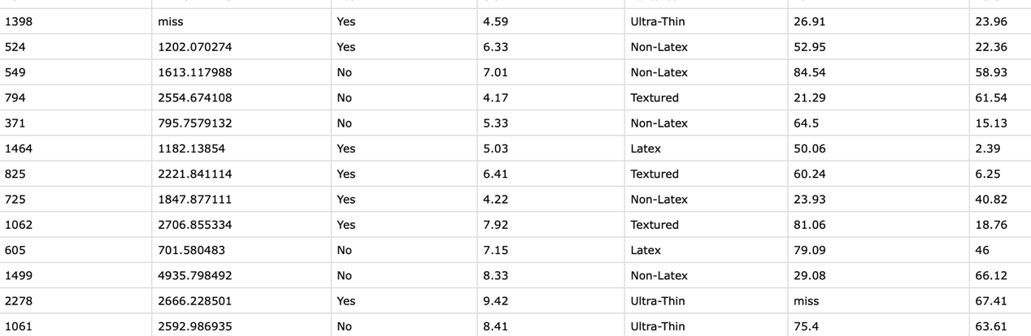
Then I have to use the function down there to find the row that changed to “miss”.
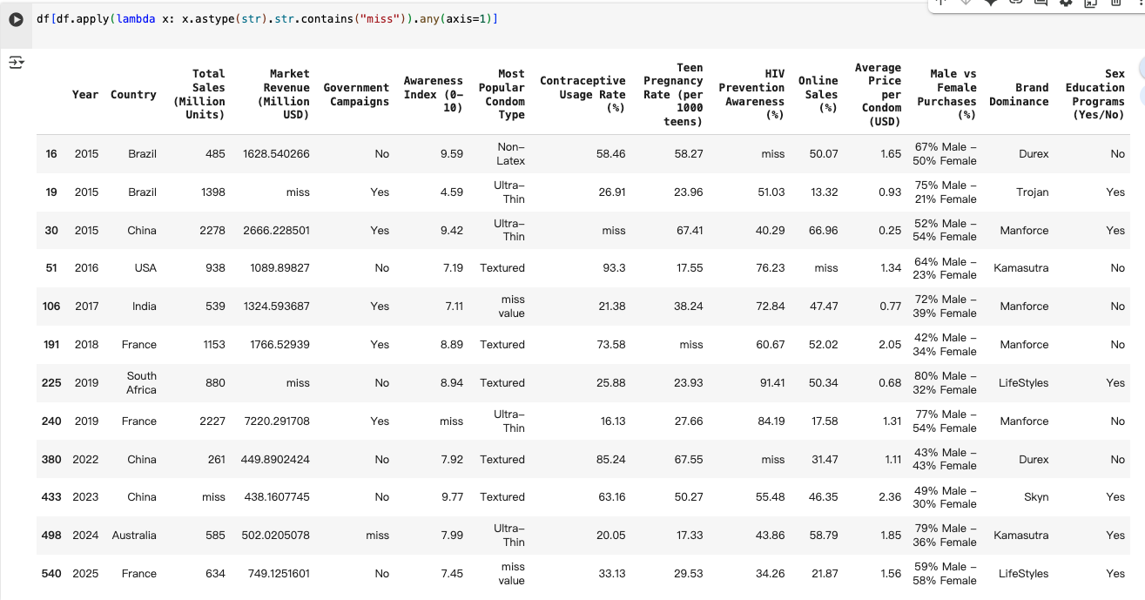
5. Conclusion
Here, we present the successfully completed Rich Global Condom Usage dataset. I can see, only looking at df. describe() the urgence-gap between countries in sales, awareness and access is fairly excessive. Some of the indicators are closely associated with things like education, awareness and, yes, even use of contraception, and even teenage pregnancy. The data is pretty clean after removing the rows with missing values and zero. Such insight is also available at the summary statistics and correlation analysis level as to the relations.

